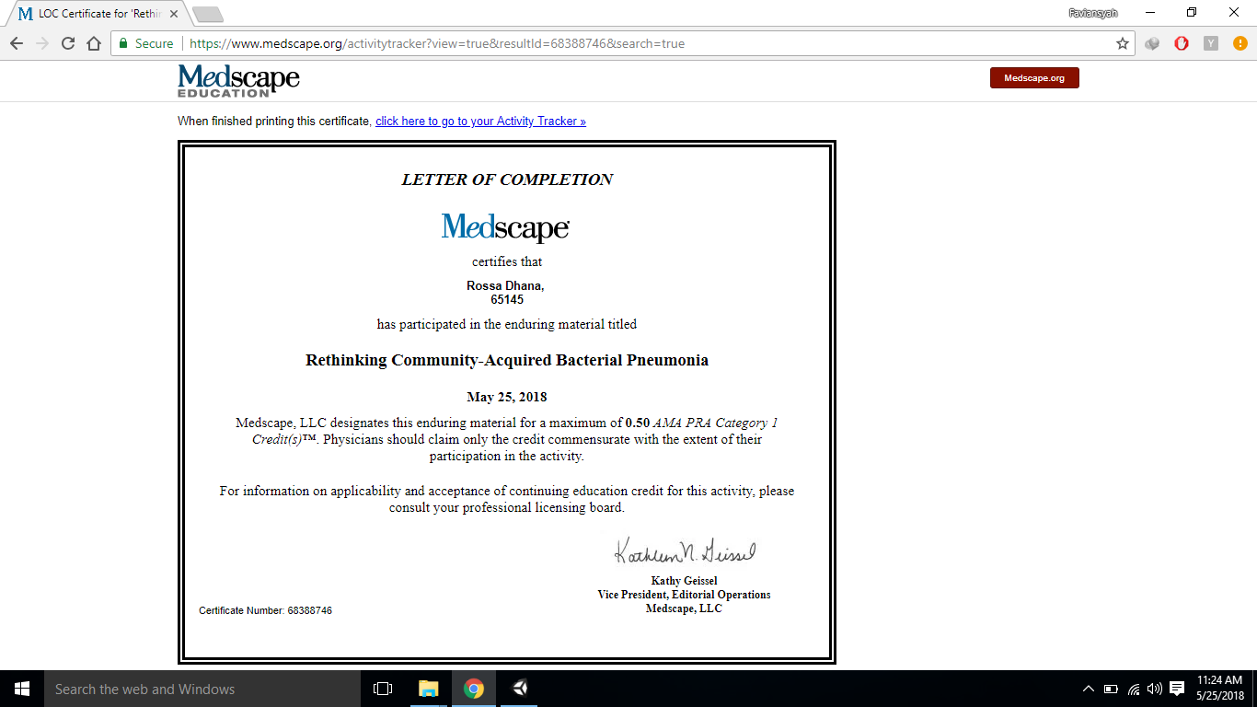

Nama: Rossa Arianda V

NIM: 155070100111011